Assignment No. 04
- TITLE – To handle fragmented data efficiently, implement simple transpose, fast transpose, and addition of sparse matrices using the 3-tuple representation. Analyse and compare the time and space efficiency of each method to understand how sparse matrix operations can optimize performance in real-world scenarios like handling large scale data fragmentations on distributed systems.

- THEORY –
1. Sparse Matrices
A sparse matrix is a matrix in which most of the elements are zero. Storing all elements in a normal 2D array wastes both memory and computation time. Instead, only the non-zero elements are stored using a compact representation.
Applications of Sparse Matrices:
- Graph algorithms (adjacency matrices).
- Search engines and recommendation systems.
- Machine learning (large datasets with many missing values).
- Distributed systems where data is fragmented.

2. Triplet (3-Tuple) Representation
The triplet representation stores only the non-zero elements of a sparse matrix. Each element is represented as:
(row,column,value)(row, column, value)(row,column,value)
The first entry usually stores metadata:
- row = total number of rows
- col = total number of columns
- value = total number of non-zero elements
This reduces space complexity from O(rows × cols) to O(nz), where nz = number of non-zero elements.

3. Sparse Matrix Operations
a) Simple Transpose
- Swaps row and column indices of each element.
- Implementation: Scan column by column, copy elements with swapped indices.
- Time Complexity: O(nz × cols) (can be slow for large matrices).
b) Fast Transpose
- Improves efficiency by precomputing positions of elements using a count array.
- Steps:
  - Count the number of elements in each column.
  - Compute starting index for each column in the transposed matrix.
  - Place elements directly in correct positions.
- Time Complexity: O(nz + cols) → faster than simple transpose.
c) Addition of Sparse Matrices
- Convert both matrices into triplet form.
- Compare positions (row, col) of non-zero elements:
  - If positions match → add values.
  - Else → insert element directly.
- Time Complexity: O(nz1 + nz2) where nz1 and nz2 are non-zero counts.

4. Time and Space Efficiency
Operation | Normal Matrix (Dense) | Sparse Triplet Representation
Storage | O(rows × cols) | O(nz)
Simple Transpose | O(rows × cols) | O(nz × cols)
Fast Transpose | O(rows × cols) | O(nz + cols)
Addition | O(rows × cols) | O(nz1 + nz2)

- Space Efficiency: Saves memory for large, mostly zero matrices.
- Time Efficiency: Operations are performed only on non-zero elements, reducing runtime.

5. Real-World Relevance
- Distributed Systems → Handle fragmented data efficiently by reducing network and memory overhead.
- Graph Algorithms → Store adjacency matrices compactly.
- Machine Learning → Work with high-dimensional but sparse datasets.
- Scientific Computing → Solve large systems with minimal storage.

- ALGORITHM –
A. Triplet Representation
- Input matrix dimensions (rows, cols) and elements.
- Count non-zero elements (nz).
- Create a triplet array of size (nz+1) × 3.
  - First row → (rows, cols, nz) (metadata).
  - Remaining rows → (row_index, col_index, value) for each non-zero element.
- Print triplet form.
B. Simple Transpose
- Initialize transposed triplet array with swapped dimensions.
- For each column in original, scan all elements and if found → store (col, row, value).
- Print result.
C. Fast Transpose
- Create an array count[col] → store number of non-zero elements per column.
- Compute start[col] → index where that column’s elements should start in result.
- Traverse original triplet and directly place (col, row, value) in correct index of transposed array.
- Print result.
D. Addition of Sparse Matrices
- Generate triplet representations of both matrices.
- Compare elements of both triplets by (row, col).
  - If positions match → add values.
  - If not → copy smaller one directly.
- Store results in new triplet array.
- Print result.

- EXAMPLE –

Matrix A (4 × 5)
0 0 3 0 4
0 0 5 7 0
0 0 0 0 0
0 2 6 0 0

Matrix B (4 × 5)
0 0 0 0 5
0 0 2 0 0
0 8 0 0 0
0 0 7 0 0

Triplet Representation of A
Row Col Val
4 5 6 <- (rows, cols, non-zero count)
0 2 3
0 4 4
1 2 5
1 3 7
3 1 2
3 2 6

Triplet Representation of B
Row Col Val
4 5 5
0 4 5
1 2 2
2 1 8
3 2 7

Simple Transpose of A
Row Col Val
5 4 6
2 0 3
4 0 4
2 1 5
3 1 7
1 3 2
2 3 6

Fast Transpose of A
Row Col Val
5 4 6
1 3 2
2 0 3
2 1 5
2 3 6
3 1 7
4 0 4

Addition of A + B
Row Col Val
4 5 8
0 2 3
0 4 9
1 2 7
1 3 7
2 1 8
3 1 2
3 2 13

- CODE –
1. sparse_matrix.cpp
#include <iostream>
using namespace std;

struct Triple{
int row;
int col;
int value;
};

int main(){
int rows, cols, nz=0;
cout<<"Enter number of rows and columns respectively: "<<endl;
cin>>rows>>cols;
int matrix[rows][cols];
cout<<"Enter elemens of matrix: "<<endl;
for(int i = 0;i < rows;i++){
for(int j = 0; j<cols; j++){
cin>>matrix[i][j];
if(matrix[i][j]!=0){
nz++;
}
}
}

Triple sparse[nz+1];
sparse[0].row = rows;
sparse[0].col = cols;
sparse[0].value = nz;

int k = 1;
for(int i = 0;i< rows;i++){
for(int j =0;j< cols;j++){
if(matrix[i][j]!=0){
sparse[k].row = i;
sparse[k].col = j;
sparse[k].value = matrix[i][j];
k++;
}
}
}

cout<<"The sparse matrix is: "<<endl;
cout << "Row\tCol\tValue" <<endl;
for(int i = 1;i <= nz;i++){
cout<<sparse[i].row<<"\t "<<sparse[i].col<<" \t"<<sparse[i].value<<endl;
}

Triple simple[nz+1];
simple[0].row = sparse[0].col;
simple[0].col = sparse[0].row;
simple[0].value = sparse[0].value;

int t = 1;
for(int col = 0; col < cols; col++) {
for(int i = 1; i <= nz; i++) {
if(sparse[i].col == col) {
simple[t].row = sparse[i].col;
simple[t].col = sparse[i].row;
simple[t].value = sparse[i].value;
t++;
}
}
}

cout << "The simple transpose sparse matrix is:" << endl;
cout << "Row\tCol\tValue" << endl;
for(int i = 1; i <= nz; i++) {
cout << simple[i].row << "\t" << simple[i].col << "\t" << simple[i].value << endl;
}

Triple fast[nz + 1];
fast[0] = {cols, rows, nz};

int count[cols] = {0}, index[cols];

for (int i = 1; i <= nz; i++){
count[sparse[i].col]++;
}

index[0] = 1;
for (int i = 1; i < cols; i++){
index[i] = index[i - 1] + count[i - 1];
}

for (int i = 1; i <= nz; i++) {
int col = sparse[i].col;
int pos = index[col]++;
fast[pos] = {sparse[i].col, sparse[i].row, sparse[i].value};
}

cout << "The fast transpose sparse matrix is:" << endl;
cout << "\nRow\tCol\tValue\n";
for (int i = 1; i <= nz; i++){
cout << fast[i].row << "\t" << fast[i].col << "\t" << fast[i].value << endl;
}
return 0;
}

2. AddSparse.cpp
#include <iostream>
using namespace std;
struct Triple{
int row;
int col;
int value;
};
int main(){
int r1, r2, c1, c2;
cout<<"Enter number of rows and columns of first matrix respectively: "<<endl;
cin>>r1>>c1;
cout<<"Enter number of rows and columns of second matrix respectively: "<<endl;
cin>>r2>>c2;
if(c1!=c2||r1!=r2){
cout<<"Matrix multiplication not possible"<<endl;
return 0;
}
int matrix1[r1][c1], matrix2[r2][c2];
cout<<"Enter elements of first matrix: "<<endl;
for(int i = 0;i < r1;i++){
for(int j = 0; j<c1; j++){
cin>>matrix1[i][j];
}
}
cout<<"Enter elements of second matrix: "<<endl;
for(int i = 0;i < r2;i++){
for(int j = 0; j<c2; j++){
cin>>matrix2[i][j];
}
}
int nz1=0, nz2=0;
for(int i = 0;i < r1;i++){
for(int j = 0; j<c1; j++){
if(matrix1[i][j]!=0){
nz1++;
}
if(matrix2[i][j]!=0){
nz2++;
}
}
}
Triple sparse1[nz1+1], sparse2[nz2+1];
sparse1[0].row = r1;
sparse1[0].col = c1;
sparse1[0].value = nz1;
sparse2[0].row = r2;
sparse2[0].col = c2;
sparse2[0].value = nz2;

int k = 1;
for(int i = 0;i< r1;i++){
for(int j =0;j< c1;j++){
if(matrix1[i][j]!=0){
sparse1[k].row = i;
sparse1[k].col = j;
sparse1[k].value = matrix1[i][j];
k++;
}
}
}
k = 1;
for(int i = 0;i< r2;i++){
for(int j =0;j< c2;j++){
if(matrix2[i][j]!=0){
sparse2[k].row = i;
sparse2[k].col = j;
sparse2[k].value = matrix2[i][j];
k++;
}
}
}
cout<<"The sparse matrix 1 is: "<<endl;
cout << "Row\tCol\tValue" <<endl;
for(int i = 1;i <= nz1;i++){
cout<<sparse1[i].row<<"\t "<<sparse1[i].col<<" \t"<<sparse1[i].value<<endl;
}
cout<<"The sparse matrix 2 is: "<<endl;
cout << "Row\tCol\tValue" <<endl;
for(int i = 1;i <= nz2;i++){
cout<<sparse2[i].row<<"\t "<<sparse2[i].col<<" \t"<<sparse2[i].value<<endl;
}

Triple result[nz1+nz2+1];
result[0].row = r1;
result[0].col = c1;
int p=1;
for(int i=1;i<=nz1;i++){
result[p]=sparse1[i];
p++;
}
for(int i=1;i<=nz2;i++){
bool found=false;
for(int j=1;j<p;j++){
if(sparse2[i].row==result[j].row && sparse2[i].col==result[j].col){
result[j].value+=sparse2[i].value;
found=true;
break;
}
}
if(!found){
result[p]=sparse2[i];
p++;
}
}
result[0].value=p-1;
cout<<"The resultant sparse matrix after addition is: "<<endl;
cout << "Row\tCol\tValue" <<endl;
for(int i = 1;i < p;i++){
cout<<result[i].row<<"\t "<<result[i].col<<" \t"<<result[i].value<<endl;
}
return 0;
}

- OUTPUT –
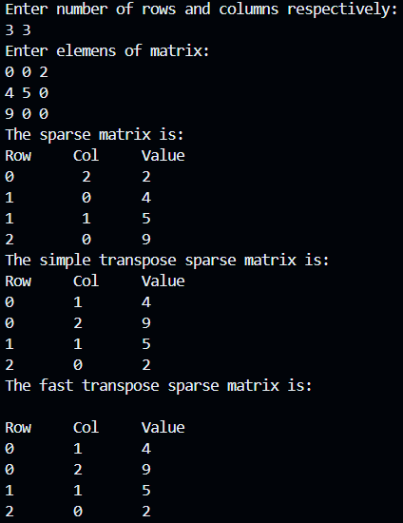
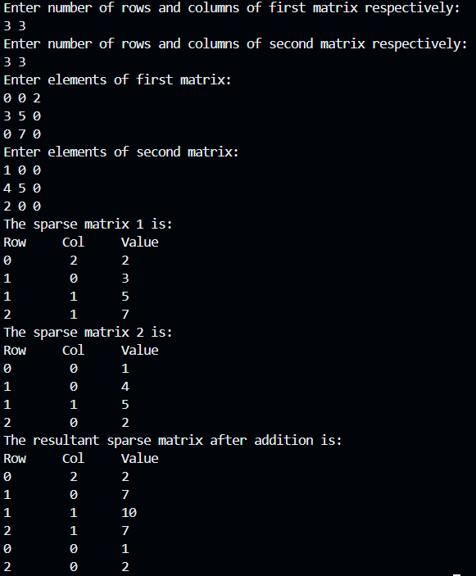

- CONCLUSION –
In this practical, we have observed that Sparse matrices allow efficient storage and operations by focusing only on non-zero elements. Using the triplet representation, operations like fast transpose and addition reduce both memory usage and computation time, making them highly suitable for large-scale and real-world applications.

